7. ARRAY OPERATIONS(INSERT,DELETE,DISPLAY)

**Aim**

To write a C program to perform **array operations** such as **insertion, deletion, and display** of elements.

**Algorithm**

1. **Start**
2. Initialize an array and a variable n to store the number of elements.
3. **Insert Operation:**
   * Read the element and position.
   * Shift elements from the given position to the right.
   * Insert the new element at the specified position.
   * Increase the size n.
4. **Delete Operation:**
   * Read the position to delete.
   * Shift elements from the next position to the left.
   * Decrease the size n.
5. **Display Operation:**
   * Traverse through the array and print all elements.
6. Repeat the menu until the user chooses to exit.
7. **Stop**

**PROGRAM**

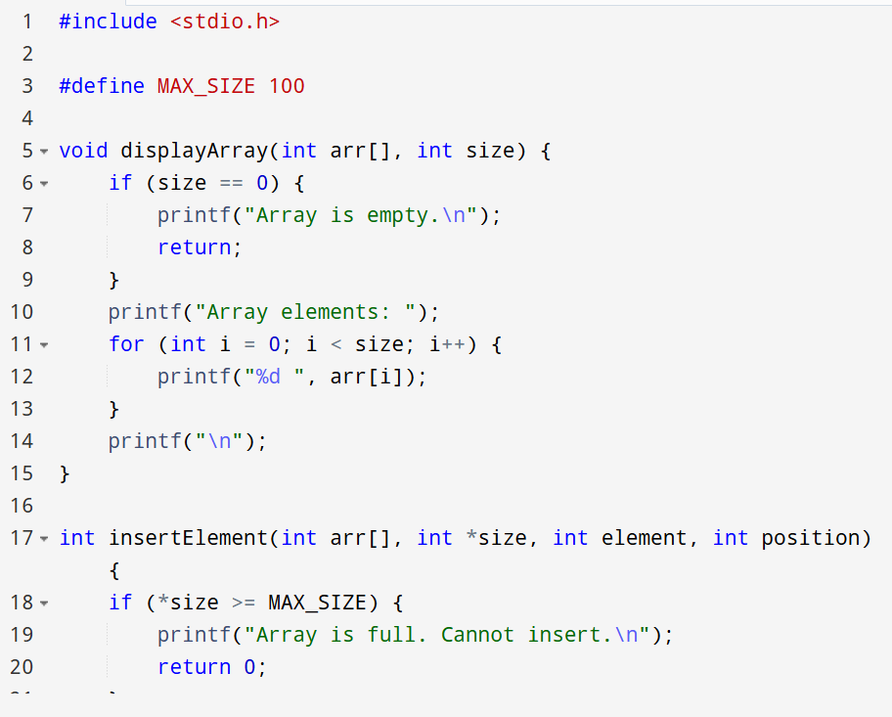

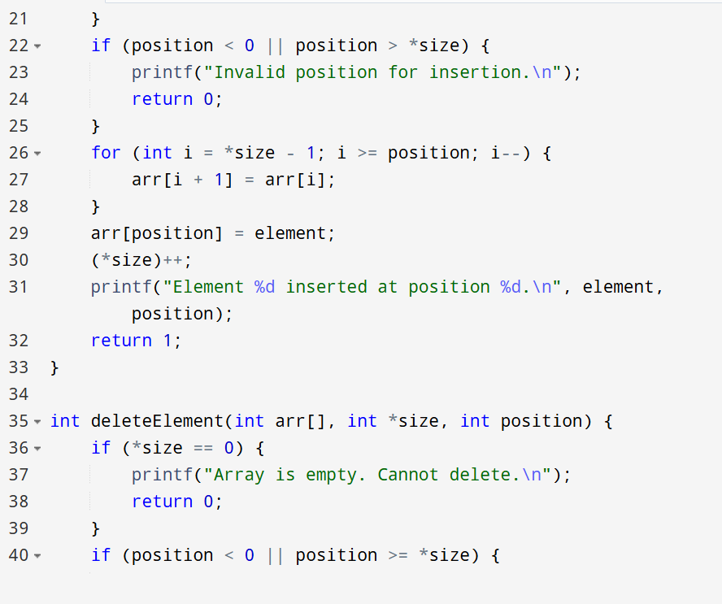

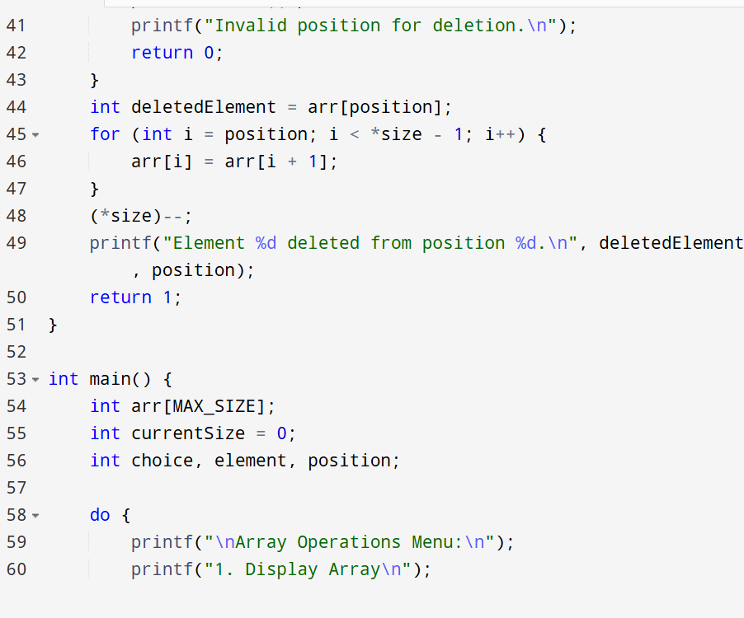

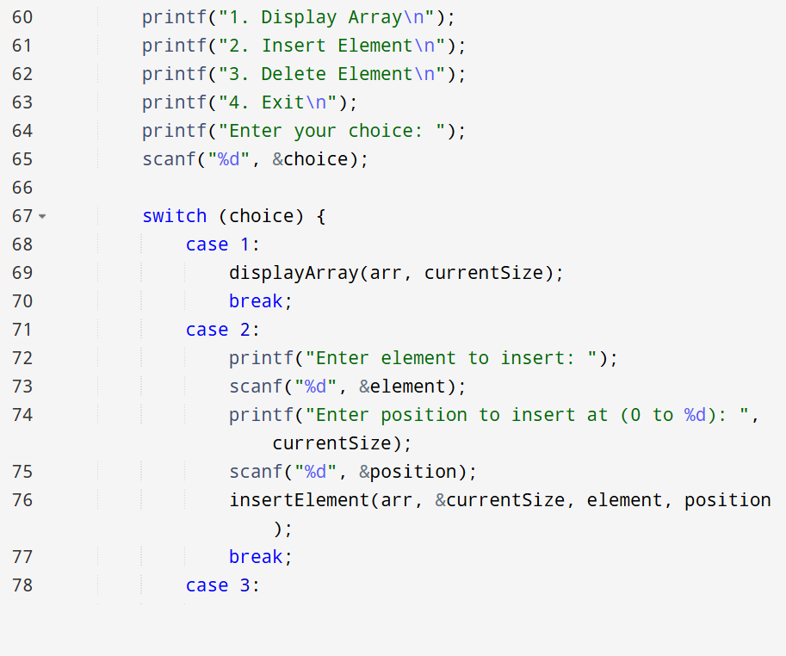OOU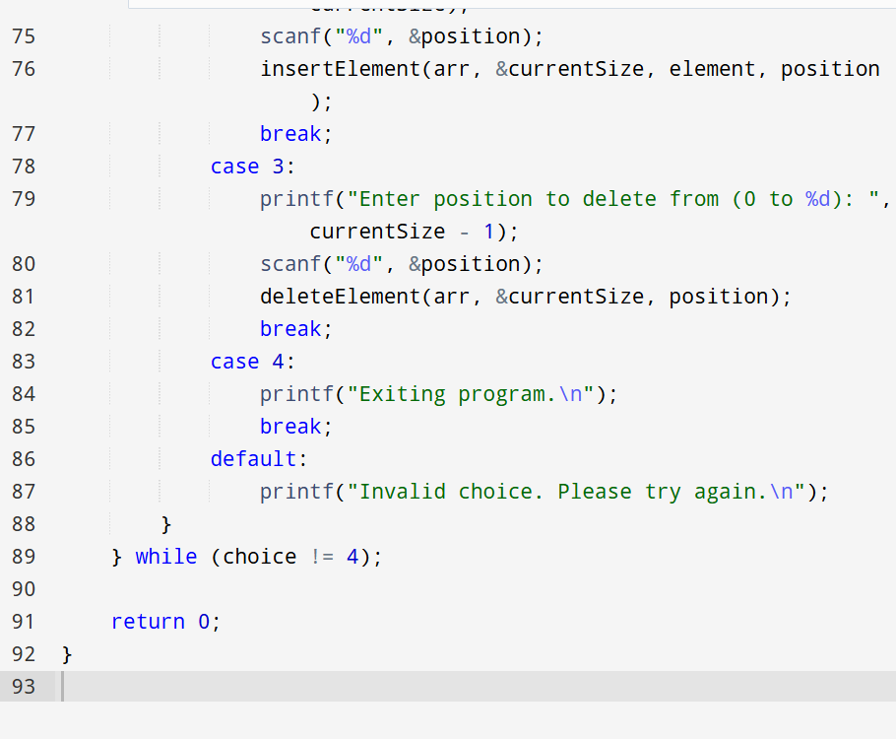

OUTPUT

